**Capstone Project   
  
1.Build an environment to run Terraform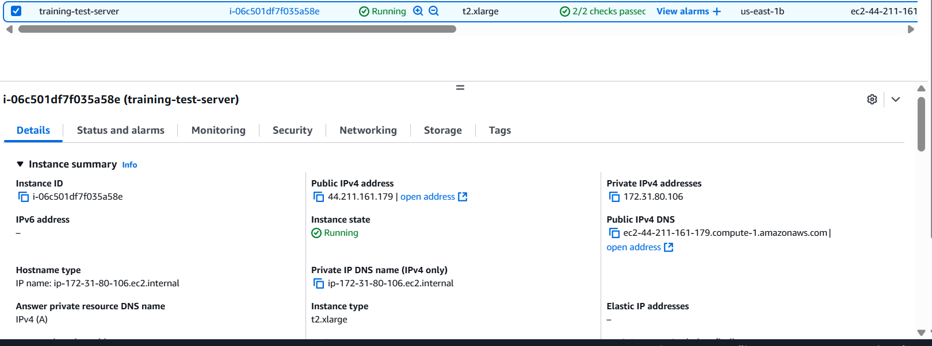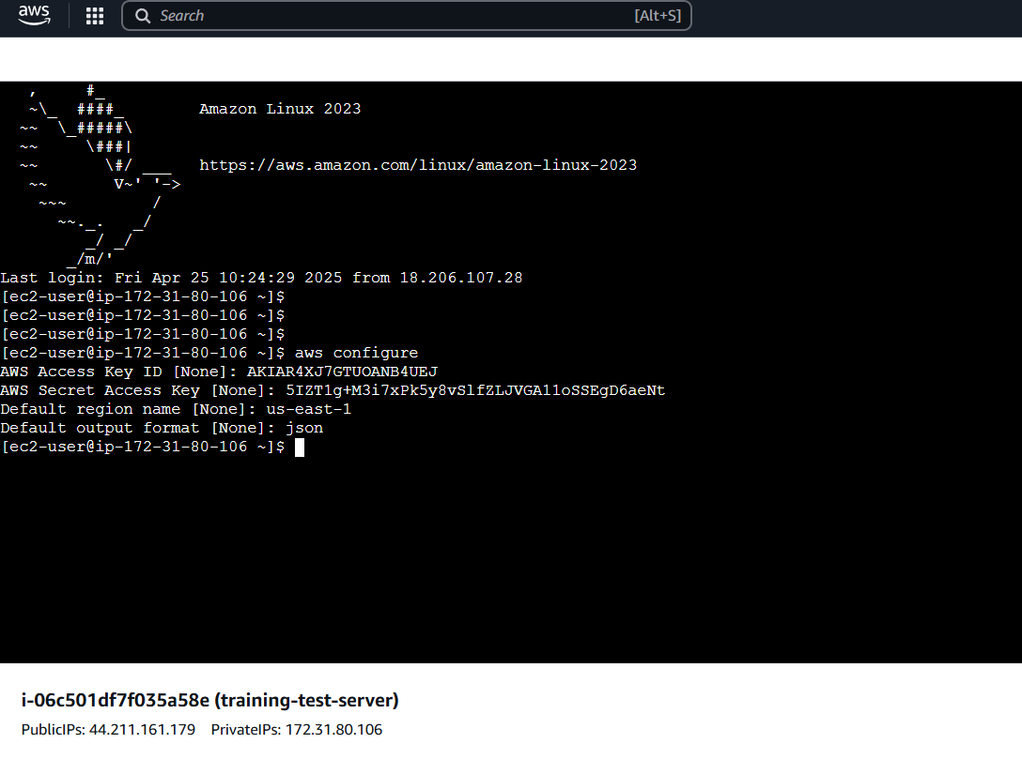 2.Install the Terraform and associated software and ensure it works properly  
  
terraform is installed and other software and verified.  
  
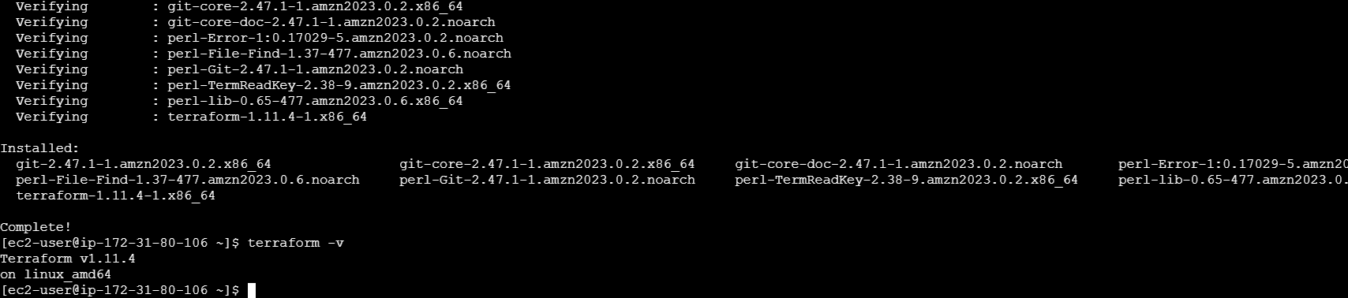  
  
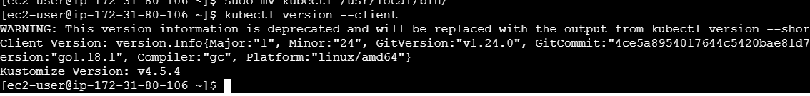  
  
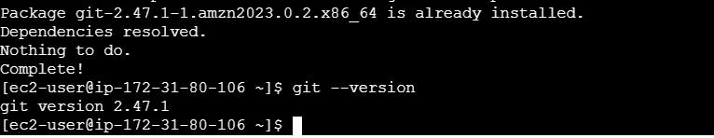  
  
  
3. Test the environment by creating a simple virtual machine  
  
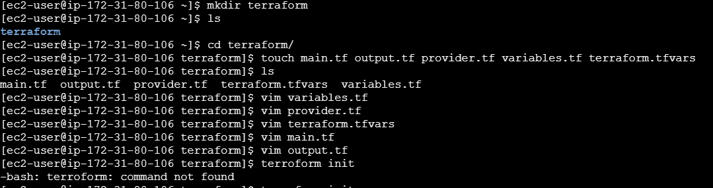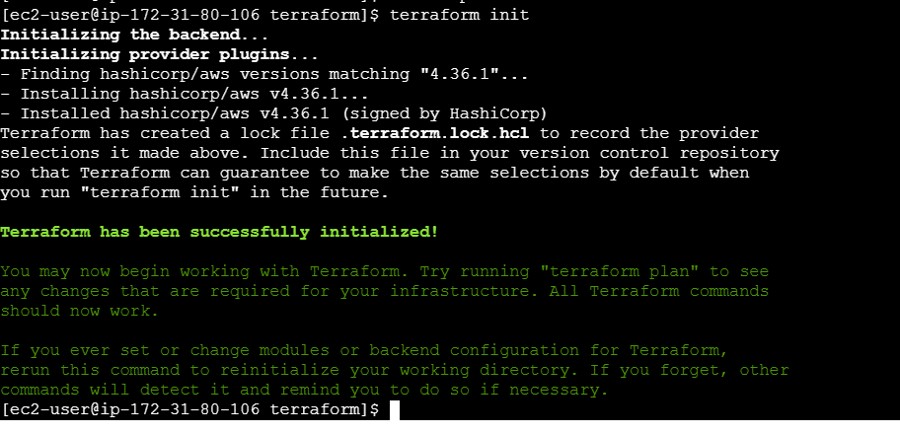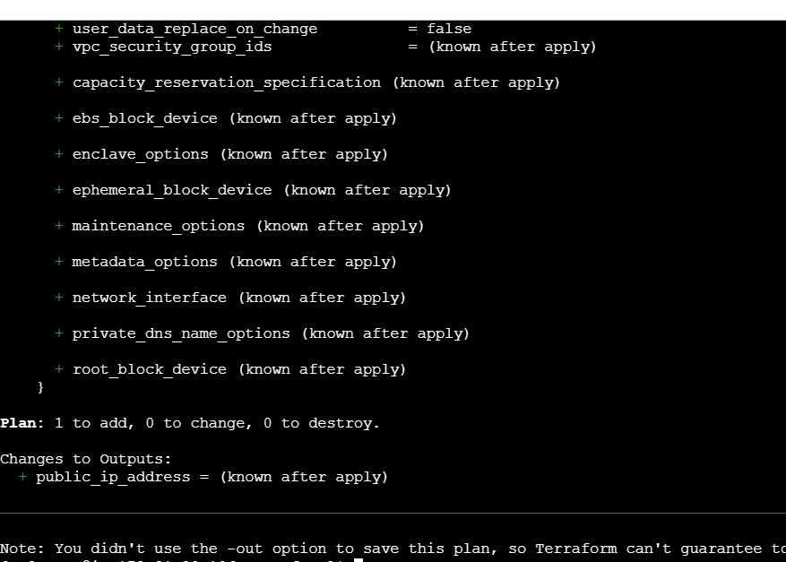 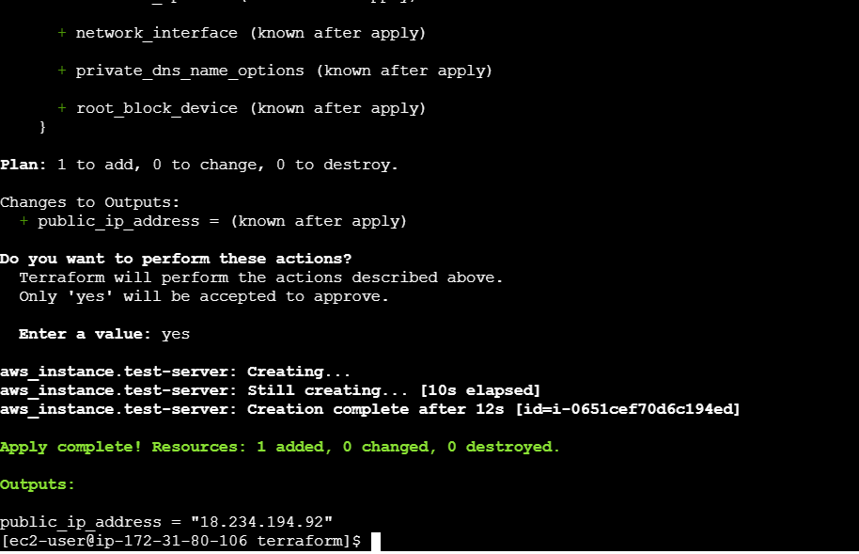  
  
Created new server using terraform :  
  
